|  |  |
| --- | --- |
| GEF-notag-lowres_0 |  |
| **UNDP-GEF PPG Initiation Plan** | |

1. **Background:**

The purpose of the GEF PPG is to describe how the project preparation grant from the GEF will be programmed to develop a full project document with supporting documentation for submission to the GEF for CEO endorsement.

When a project preparation grant has been requested by completing Section E of the PIF template, these resources are confirmed and can be programmed upon receipt of the GEF CEO letter entitled “PIF Clearance for WP Inclusion and PPG Approval”. In general, for medium-sized projects (MSPs) using the one-step approval process, the costs of project preparation can be reimbursed by completing Section G of the one-step MSP CEO approval template. For child projects under a program, a project preparation grant can be requested at the same time as the PFD is submitted to Council or after Council approves the PFD. See GEF’s 2017 [Guidelines on the GEF Project and Programing Policy](https://www.thegef.org/sites/default/files/council-meeting-documents/EN_GEF.C.52.Inf_.06_Guidelines_on_the_Project_and_Program_Cycle_Policy_0.pdf) for additional details.

The standard template for the GEF PPG, included in this file, lists project development activities that are necessary to complete mandatory sections of the 2017 UNDP-GEF Project Document (e.g. Theory of Change, Gender Analysis, SESP, etc.) and should therefore not be removed from the template. Supplementary guidance is indicated in *italicized and blue-highlighted text*. Additional eligible project development activities can be added to as necessary.

The 2017 UNDP-GEF Project Document template can be found [here](https://intranet.undp.org/unit/bpps/sdev/gef/Templates1/Annotated%20UNDP%20GEF%20Project%20Document%20Template%2011%20July%202017.doc) and the GEF CEO Endorsement Request template can be found [here](https://www.thegef.org/gef/guidelines_templates).

1. **Eligible activities:**

The GEF project preparation grant is not an advance on the project grant and can therefore not be used to finance implementation activities.

Please refer to the GEF’s 2017 [Guidelines on the GEF Project and Programing Policy](https://www.thegef.org/sites/default/files/council-meeting-documents/EN_GEF.C.52.Inf_.06_Guidelines_on_the_Project_and_Program_Cycle_Policy_0.pdf) for a list of eligible project preparation activities, and take note of the following ineligible expenditures:

* Costs associated with the work of government staff or regular project/program activities of a GEF Agency or a Project Executing Entity (EA).
* Non-project preparation costs including: project start-up costs (i.e. Inception Workshop, travel to Convention Meetings, study tours and exchanges are not eligible); demonstration and pilot projects; implementation of large-scale enabling activities, including detailed country-wide inventories and country studies, training activities other than where they are directly related to project and/or country preparation and major research.
* Capital goods other than those directly required for project preparation, such as computers and engineering equipment. (i.e. purchase of vehicles is not eligible)
* Goods and services that can be procured through funding channels other than the GEF. (i.e. Co-financing should be used to cover costs associated with purchase of a vehicle if needed, etc.)

1. **Requirements:**

The UNDP-GEF Project Document must be finalized in English and submitted to the UNDP-GEF Unit for clearance within 16 months of PIF approval (for full-size projects) or 10 months of PIF approval (for medium-sized projects) or 2 months prior to the commitment deadline specified in the endorsed Program Framework Document (PFD).[[1]](#footnote-1)

If the fully completed Project Document is not submitted within the specified deadline set by the GEF, the project will be automatically cancelled by the GEF. See the [GEF Cancellation Policy](https://www.thegef.org/gef/sites/thegef.org/files/documents/19_EN_GEF.C.47.07_Improving_the_GEF_Project_Cycle.pdf) for additional details.

1. **UNDP Procedures for GEF PPG:**

Implementation modality: Preferred Direct Implementation Modality (DIM). Other modalities possible if government requests.

Government agreement: There must be evidence that the Government agrees to the Initiation Plan/GEF PPG, through meeting minutes, an exchange of letters or e-mails, or signing the Initiation Plan document. Please check the [POPP](https://popp.undp.org/SitePages/POPPRoot.aspx) for the latest requirements.

GEF PPG signatures:

* Direct Implementation Modality (DIM) managed by Country Office: signed by Resident Representative.
* Direct Implementation Modality (DIM) managed by UNDP-GEF Unit: signed by UNDP-GEF Executive Coordinator.
* Agency Implementation Modality if government requests, managed by UN Agency (i.e. UNOPS): signed by Resident Representative and UN Agency (i.e. UNOPS)

Atlas requirements: A separate Award should be created in ATLAS. The following ATLAS set up is required: one project ID = one output ID.

Gender marker: As all GEF PPGs are required to prepare a gender analysis and action plan, the gender marker rating should be GEN 2 or GEN 3.

UNDP Quality Assurance: The UNDP quality assurance report (design, implementation and closure) is not required and should be marked as “exempt” from QA in the Corporate Planning System, and the drop down “GEF PPG” selected for the reason for exemption.

UNDP SESP: A social and environmental screening (SESP) is not required.

Language: This GEF PPG template can be completed in any language.

GEF PPG closure: Within 18 months of PIF or PFD approval, the GEF PPG must be financially closed in Atlas, and the table in Annex C of the GEF CEO Endorsement Template must be completed to report to the GEF on the use of the PPG resources. If, by exception, the activities and resources have not been fully completed by CEO endorsement, the table in Annex C of the CEO Endorsement Template must be completed within one year of CEO endorsement and be submitted to the GEF with the first Project Implementation Report (PIR). Any unspent PPG resources must be returned to the GEF (handled by UNDP-GEF HQ in New York).

|  |  |
| --- | --- |
| GEF-notag-lowres_0 |  |
| **UNDP-GEF PPG Initiation Plan** | |

|  |  |
| --- | --- |
| **Project Title:**  Managing multiple sector threats on marine ecosystems to achieve sustainable blue growth  **Country:** Cape Verde  **UNDAF Outcome (2018 version):** By 2022, all people, particularly the most vulnerable, benefit from enhanced national and local capacity to apply integrated and innovative approaches to the sustainable and participative management of natural resources and biodiversity, climate change adaptation and mitigation, and disaster-risk reduction.  **UNDP Country Programme Output:** 2.3: Enhanced legal, policy and institutional frameworks are in place for conservation, sustainable use and access, and benefit-sharing of natural resources, biodiversity and ecosystems  **UNDP Strategic Plan Output:** 1.3: Solutions developed at national and sub-national levels for sustainable management of natural resources, ecosystem services, chemicals and waste  **Gender Marker rating:** *GEN 2* | |
| Atlas Project ID (formerly Award ID): 00106034  Atlas Output ID (formerly Project ID): 00106971  UNDP PIMS ID: 5880  GEF PMIS ID: 9705  Management Arrangement: DIM | **Total budget: US$ 100,000**  Allocated resources:   * GEF US$ 100,000 * Government * UNDP |

Agreed by

|  |  |  |
| --- | --- | --- |
|  |  | *Day/Month/Year* |
| UNDP Resident Representative[[2]](#footnote-2) | Signature | Date |

Table of Contents

[I. Brief Description of the Initiation Plan/GEF PPG 5](#_Toc501629161)

[II. Stakeholder Engagement, public disclosure and other requirements 6](#_Toc501629162)

[III. GEF PPG ACTIVITIES 7](#_Toc501629163)

[PPG Component A: Preparatory Technical Reviews & Studies and Stakeholder Consultations 7](#_Toc501629164)

[PPG Component B: Formulation of the UNDP-GEF Project Document, GEF CEO Endorsement Request, and Mandatory and Project Specific Annexes 9](#_Toc501629165)

[IV. Total Budget and Work Plan for GEF PPG 14](#_Toc501629166)

[V. GEF PPG Activities timeframe and budget 16](#_Toc501629167)

[VI. Mandatory Annexes 17](#_Toc501629168)

[Annex 1: GEF CEO PIF/PPG Approval Letter 17](#_Toc501629169)

[Annex 2: Draft Terms of Reference (TORs) of Consultants Financed by the Project Preparatory Grant (GEF PPG) 19](#_Toc501629170)

[Annex 3a: Comments on the PIF from GEF Secretariat 23](#_Toc501629171)

[Annex 3b: Comments on the PIF from GEF STAP 26](#_Toc501629172)

[Annex 3c: Comments on the PIF from GEF Council 29](#_Toc501629173)

# Brief Description of the Initiation Plan/GEF PPG

**Objective & Final Outputs**

The objective of the GEF PPG is to develop the project concept into a full project: Managing multiple sector threats on marine ecosystems to achieve sustainable blue growth. As described in the project concept (PIF), this project aims *to Strengthen systemic and institutional capacity for reducing multiple threats to globally significant marine ecosystems and achieve sustainable blue growth in Cape Verde*.

The following documents are to be consulted as background for the GEF PPG phase:

* PIF approved by GEF Council
* SESP pre-screening (of PIF)
* Comments from GEF Secretariat, Council, STAP
* [Annotated UNDP-GEF Project Document Template](https://intranet.undp.org/unit/bpps/sdev/gef/Templates1/Annotated%20UNDP%20GEF%20Project%20Document%20Template%2011%20July%202017.doc) and associated guidance included therein
* GEF CEO Endorsement Request Template and related guidance
* GEF-6 versionsof the appropriate UNDP and GEF Tracking Tool templates and related guidance

The final outputs of the GEF PPG are:

* UNDP-GEF Project Document (ProDoc), using the latest standard template.
* Mandatory annexes to the ProDoc, including gender analysis and action plan, and stakeholder engagement plan, among others, and project-specific annexes.
* GEF CEO Endorsement Request.
* Validation Workshop report (as appropriate for projects with a moderate and high SESP risk rating).

Any additional studies and other reports produced under the GEF PPG and not included in Annex to the project document will be submitted to UNDP and saved for future reference.

**Key Dates for the GEF PPG**

|  |  |  |
| --- | --- | --- |
| **Milestone** | **Date** | **Notes** |
| **Internal submission date** for UNDP-GEF review and clearance | April-May 2018 | Must be at least two (2) months prior to CEO Endorsement Deadline |
| **GEF CEO Endorsement Deadline** after which the project will be cancelled. | 23-25 May 2017 + 18 months => 23-25 November 2018 | Failure to submit a ProDoc and CEO ER to the GEF Sec by this deadline will lead to the automatic cancellation of the project by the GEF Secretariat. |

**PPG Management Arrangements**

The UNDP Country Office Cape Verde will lead the project development process and manage the GEF PPG budget in full consultation with the UNDP-GEF Regional Technical Advisor. The GEF PPG Atlas budget is presented in *Section IV: Total Budget and Work Plan*.

As appropriate, a Working Group will guide the GEF PPG team, and review and endorse the GEF PPG deliverables. The Working Group is responsible for ensuring that the deliverables outlined in this GEF PPG are completed on time and in line with UNDP and GEF requirements. The UNDP Deputy Resident Representative or her delegate will chair the Working Group. Working Group members should include:

* UNDP Country Office in Cape Verde and UNDP-GEF Regional Technical Advisor
* FAO
* Ministry of Agriculture and Environment and National Directorate for Environment
* General Directorate for Marine Resources, Ministry of Economy and Employment
* Ministry of Finance
* AMP – Maritime and Ports Agency (Agencia Marítima e Portuária)
* National Institute for Fisheries – INDP
* ACOPESCA - Competent Authority for Fisheries Products (Autoridad Competente para os Produtos de Pesca)
* ASA – Airports and Aerial Security (Aeroportos e Segurança Aérea de Cabo Verde)
* GC / COSMAR - Coast Guard and its Operational Centre for Maritime Security (Guarda Costeira / Centro Operacional Segurança Marítima)
* UNCV-ESM Universidad de Cabo Verde / Escuela Superior do Mar.

The GEF PPG team will be composed of the following:

* International Specialist in Marine PA and Fisheries Management and GEF Project Development (PPG Team Leader)
* International Specialist in Marine Spatial Planning and Sector Mainstreaming
* International Specialist in Marine Invasive Species Pathways Management
* International Specialist in Biodiversity Finance / BIOFIN
* National Specialist in Marine Biodiversity (PPG National Focal Point)
* National Gender Mainstreaming and Local Stakeholder Engagement Specialist

Draft Terms of Reference (TORs) for each team member is included in Annex 2 of this Initiation Plan.

# Stakeholder Engagement, public disclosure and other requirements

To ensure strong country ownership, and in line with the stakeholder engagement requirements outlined in UNDP’s [Social and Environmental Standards](http://www.undp.org/content/undp/en/home/librarypage/operations1/undp-social-and-environmental-standards.html) (SES), the development of the project to be undertaken during this GEF PPG phase will be done in full consultation and close engagement with government, CSO and other relevant stakeholders – in particular those who will benefit from and be directly involved in the implementation of the project (i.e. direct project beneficiaries). A list of these stakeholders will be prepared and included in Annex to the project document.

If the Social and Environment Screening Procedure (SESP) included in Annex to the project document, has an overall safeguard risk rating of moderate or high, the following disclosure requirements apply:

1. A final validation workshop report will be prepared summarizing the outcomes of the validation workshop and other consultations undertaken during the PPG phase. This report must demonstrate strong country ownership and will become a key reference document should an environmental and social safeguard complaint/grievance be filed during project implementation.
2. Before GEF CEO endorsement (if appropriate given the GEF cancellation policy) or at the latest by the LPAC meeting, the UNDP-GEF project document, SESP and related management plans, and other relevant information/documents (e.g. ProDoc annexes) will be made available to the public on the UNDP website or [open.undp.org](http://open.undp.org/#2017). It is recommended to make these documents available for 30 days in advance of the LPAC meeting for moderate risk projects, and 120 days in advance for high risk projects.

# GEF PPG ACTIVITIES

## PPG Component A: Preparatory Technical Reviews & Studies and Stakeholder Consultations

The following technical studies and reviews will be conducted, building on the PIF and the comments received about the PIF from GEF Secretariat, GEF Council and STAP (see Annexes 3a-c).

This research should produce the background information required to prepare the ProDoc and GEF CEO Endorsement Request, including but not limited to:

* Development challenge and strategy (including threats, problems and barrier assessment);
* Review of national policy and legislative frameworks;
* Problem and solution trees developed in consultation with project stakeholders, for a robust Theory of Change (to be prepared in **PPG** **Component B**, below);
* Review of relevant past and ongoing projects for lessons; and
* Any other analyses required to address all comments on the PIF received from GEF Secretariat, GEF Council members and STAP.

|  |  |  |  |  |  |  |  |  |
| --- | --- | --- | --- | --- | --- | --- | --- | --- |
|  | **UNDP CO** | **UNDP-GEF RTA** | **PPG Team Leader** | **MSP & Mainstream** | **IAS** | **BIOFIN** | **Marine BD** | **Gender & Local Stakeh** |
|  |  |  | **IC** | **IC** | **IC** | **IC** | **National** | **National** |
| * Regular exchanges between the UNDP Country Office, UNDP-GEF RTA, Government Partners and further stakeholders on the development and finalization of the PRODOC and GEF CEO Endorsement Request package. | Lead on site | Join remotely | Lead on site or remotely | Join on site or remotely | Join on site or remotely | Join on site or remotely | Join on site | Join on site |
| * PPG inception: at the onset of the PPG, bring together the leading stakeholders from government, partners and UNDP (country office and RTA), as well as the team of PPG consultants to agree on process and roles and quality assurance; depending on timelines and availability, this may involve participants participating online. | Lead on site | Join on site or remotely | Lead on site | Join on site | Join on site or remotely | Join on site or remotely | Join on site | Join on site |
| * Stakeholder analysis and engagement: |  |  |  |  |  |  |  |  |
| * + building on the tentative list of stakeholders already identified in the PIF, further elaborate the analysis of relevant stakeholder, especially with regard to their contribution and roles in the project; in response to GEF STAP and Council comments, reach out also to Abidjan Convention, ICCAT and the FAO-implemented Canary Current Large Marine Ecosystem project’s Strategic Action Programme. | Support | Support | Lead | Support | Support | Support | Support | Support |
| * + determine entry points that will yield the highest leverage for strengthening the management of marine and coastal biodiversity in Cape Verde, including through the emerging national Blue Growth Strategy; | Lead | Support | Support | Support | Support | Support | Lead | Support |
| * + to secure a strong national ownership, engage and sensitise key government representatives and other stakeholders about the project and ensure their full participation and agreement in the development of the project strategy and design. | Lead |  | Lead | Support | Support | Support | Lead | Lead |
| * Identify other relevant existing and planned initiatives, possibly negotiating partnerships to align activities and build synergies, and reflecting this in the project strategy. | Support | Support | Lead | Support | Support | Support | Lead | Support |
| * **Desktop and field-based studies and data collection**, to further elaborate the situation analysis and project interventions (building on the PIF). This will include *inter alia*: |  |  |  |  |  |  |  |  |
| * + review of all the relevant national and sector development plans, policies and budgets to further respond to and align the project with government goals and priorities; | Support | Support | Lead | Lead | Lead | Lead | Support | Support |
| * + research to establish/confirm the baseline investment of the government and its partners in relation to the issues to be addressed by the project, in order to help determine the incrementality of the GEF intervention; | Support |  | Lead | Support | Support | Support | Lead | Support |
| * + an assessment of institutional/technical/individual capacity development needs for key stakeholder groups on marine and coastal biodiversity, marine living resources, marine protected areas, MPA and fisheries co-management and surveillance, invasive alien species, IMO conventions, biodiversity finance, and sector mainstreaming and marine spatial planning; | Support | Support | Lead | Support | Support | Support | Lead | Support |
| * + assessment of suitable PA and fisheries surveillance tools including most notably drones; |  | Support | Lead |  |  |  | Support |  |
| * + preliminary assessment of IAS pathways in Cape Verde and definition of a strategy for the project to mitigate IAS risks in Cape Verde; |  | Support | Support |  | Lead |  | Lead |  |
| * + any further research and data collection required to confirm or define suitable objective-level and outcome-level indicators and their baseline values and end-of-project targets; this will include *inter alia*: defining baseline management effectiveness in the targeted PAs; defining baseline IAS prevention and management frameworks in place; determining baseline financial flows for PA system management; determining baseline values for suitable proxy indicator species (*Epinephelus* sp. # in dive transects or fixed underwater camera field of view; # shark dive sightings; # sea-turtle nests and sightings; # of seabirds; coral cover, diversity and condition in transects; etc.) |  |  | Lead | Lead | Lead | Lead | Lead | Support |
| * + international benchmarking of adequacy, incrementality and cost-effectiveness of the project’s interventions; to respond to GEF-STAP, this should include *a rigorous assessment of whether this complex project is* ***feasible*** *within the project time frame and capacity, and the capacity [and buy in] of implementing agencies to deliver the project*, engaging *with the relevant stakeholders that will need to be involved (through a workshop)* |  | Support | Lead | Lead | Support | Support | Support | Support |
| * + **Environmental and Social Safeguard Assessments.** The social and environmental safeguards pre-screening (pre-SESP) prepared during the PIF design phase determined the overall risk categorization of this project as *Moderate* and highlighted potential safeguard risks to be further assessed during the PPG phase. The purpose of these assessments is to identify ways to avoid negative environmental and social impacts where possible (e.g., through site selection). If risk avoidance is not possible, then mitigation and management measures must be identified, in line with the UNDP Social and Environmental Standards (see section B-f below). If the required assessments cannot be undertaken or finalized during the PPG, they must be completed during the first phase of project implementation. |  |  | Lead | Support | Support | Support | Support | Lead |
| * + Prepare a **Gender Analysis** to fully consider the different needs, roles, benefits, impacts, risks, differential access to and control over resources of women and men (including considerations of intersecting categories of identity such as age, social status, ethnicity, marital status, etc.) given a project’s context, and to identify appropriate measures to address these and promote gender equality and women’s empowerment. The analysis will form the basis of a Gender Action Plan and Budget (see PPG Component B). | Support | Support | Lead | Support |  |  |  | Lead |
| * **Identification of project sites.** Based on the above reviews, and through consultation with stakeholders, the targeted project sites will be identified. | Support | Support | Lead | Support | Lead | Support | Lead | Lead |

## PPG Component B: Formulation of the UNDP-GEF Project Document, GEF CEO Endorsement Request, and Mandatory and Project Specific Annexes

Based on the technical studies and reviews undertaken under **PPG** **Component A** (detailed above), the full UNDP-GEF Project Document (following the 2017 annotated UNDP-GEF Project Document available [here](https://intranet.undp.org/unit/bpps/sdev/gef/Templates1/Annotated%20UNDP%20GEF%20Project%20Document%20Template%2011%20July%202017.doc)) and GEF CEO Endorsement Request (available [here](https://www.thegef.org/gef/guidelines_templates)) will be prepared, with the required complementary documentation. The following table provides the necessary details as well as instructions on several areas of the PRODOC requiring special focus. The GEF PPG Team Leader will be responsible for the consolidation and finalization of all required materials.

|  |  |  |  |  |  |  |  |  |
| --- | --- | --- | --- | --- | --- | --- | --- | --- |
|  | **UNDP CO** | **UNDP-GEF RTA** | **PPG Team Leader** | **MSP & Mainstream** | **IAS** | **BIOFIN** | **Marine BD** | **Gender & Local Stakeh** |
|  |  |  | **IC** | **IC** | **IC** | **IC** | **National** | **National** |
| * **Financial planning.**    + Undertake consultations with partners to secure a coherent and sustainable financing package for the project, including post-GEF grant phase to the extent possible. Confirm co-financing pledges from the PIF stage and identify further co-financing opportunities as required.   + Ensure issuance of official co-financing letters/guarantees to be collected from participating government institutions, bilateral development partners, multilateral development partners, NGOs, private sector, or others who commit to provide cash or in-kind contributions to the project. | Lead | Support | Lead | Support |  |  | Support |  |
| * Building on the PIF and the above consultations and background research, **formulate/consolidate the full PRODOC** with all relevant sections and annexes following the latest standard GEF-6 templates. This includes *inter alia*: |  |  | Lead | Support | Support | Support | Support | Support |
| * + Consolidating the summary problem, baseline investment and barrier analyses; |  |  | Lead | Support | Support | Support | Support | Support |
| * + **Theory of Change.** The detailed theory of change (ToC), based on the studies and data collection undertaken in PPG Component A, will be developed. The selected approach will be identified, with a clear rationale backed by credible evidence, integrating gender concerns into the approach. Additional guidance is available in the Annotated UNDP-GEF ProDoc template. |  |  | Lead | Support | Support | Support | Support | Support |
| * + Elaborating adequate and technically robust project interventions in detail, defining incrementality and cost-effectiveness of the project’s interventions; and addressing/integrating the suggestions made and opportunities/risks identified in the context of PIF approval, by GEF Secretariat, GEF STAP, and GEF Council (see Annexes 3a-c); |  |  | Lead | Lead | Lead | Lead | Support | Support |
| * + **Stakeholder Engagement Plan**. Based on the consultations undertaken during the PPG phase, a Stakeholder Engagement Plan will be developed. | Support |  | Lead | Lead | Support | Support | Support | Support |
| Gender Action Plan and Budget. Based on the Gender Analysis conducted in PPG Component A, the Gender Action Plan and Budget will outline the gender-specific outputs to be delivered during project implementation in order to promote gender equality and women’s empowerment and to ensure that inequalities are not exacerbated. As part of the work of preparing the Gender Action Plan, indicators should be proposed for inclusion in the Results Framework to facilitate the monitoring of the proposed gender mainstreaming actions. The Gender Budget must be integrated into the Total Budget and Work Plan. The Gender Analysis as well as the Gender Action Plan and Budget must be attached as Annexes to the Project Document. See guidance available [here](https://intranet.undp.org/unit/bpps/sdev/gef/SitePages/Gender.aspx). | Support | Support | Lead |  |  |  |  | Lead |
| * + **Monitoring and Evaluation (M&E) Plan and Budget.** Starting from the standard template provided in the UNDP-GEF project document template that reflects the mandatory requirements of the UNDP-GEF M&E Policy, develop a detailed M&E Plan and Budget, adding further elements allowing considering especially the dedicated Component 4 in this project. The on-the-ground monitoring could be undertaken by national institutes/universities as appropriate. Clarify the roles of various groups involved in project M&E, how project-level monitoring links with data collected at the national level, and specify the frequency of monitoring. Specify monitoring tools to be used; clarify responsibilities for completing the mid-term and terminal GEF Tracking Tools (see below). Complete the M&E budget included in the UNDP-GEF Project Document noting that the total budget should be between 3-5% of the GEF grant. |  |  | Lead | Support | Support | Support | Support | Support |
| * + **Results Framework**. Based on the studies and data collection undertaken in PPG Component A, the Results Framework will be defined with appropriate Objective-level and Outcome-level quantitative and qualitative SMART indicators and mid-term and end-of-project targets. Building on the tentative framework in the PIF, it will be designed in line with the following parameters:     - Do not include outputs or activities in the results framework. Outputs and corresponding indicators can be included in the results section and/or in Annex to the project document.     - Prepare a maximum of 2-3 indicators for the Objective and each Outcome. Aim to keep the total number of indicators in the results framework (and that require annual reporting to the GEF) to 15-16.     - Aim to include state indicators (e.g. spatial coverage, ecosystems quality, species populations), pressure indicators (threats and drivers) and response indicators;     - To respond to a comment from GEF Secretariat, add SMART Indicators related to Aichi Targets.     - Include also a suitable outcome and indicator from the *UNDP Integrated Results and Resources Framework*.     - Give special attention to include gender-responsive outcomes and other socio-economic benefits.     - Define baseline values for each indicator, using PPG research and existing national information.     - Disaggregate indicators by sex, including number of direct project beneficiaries.     - Set realistic mid-term targets and end-of-project targets that can be achieved by project closure.     - Summarize risks and assumptions, and sources of verification/data.     - *See the annotated UNDP-GEF Project Document template for additional guidance on developing the Results Framework.* |  | Support | Lead | Lead | Lead | Lead | Support | Support |
| * + Preparing a detailed**, multi-year Total Budget and Work Plan** for the project, following the standard format provided in the UNDP-GEF ProDoc template; the principal TBWP table will allocate the GEF resources, any UNDP resources, as well as any futher resources to be directly managed by UNDP over the lifetime of the project. | Support |  | Lead | Support | Support | Support | Support | Support |
| Social & Environmental Standards and Project Risks  * + - In line with the assessments conducted during PPG Component A (above) and in line with [UNDP’s Social and Environmental Standards (SES) policy and all associated SES Guidance Notes](https://info.undp.org/sites/bpps/SES_Toolkit/default.aspx), a full SESP will be prepared and all moderate and high risks identified in the SESP will be reflected in the risk table and risk section of the project document.     - Mitigation and management measures for moderate and high risks will be developed and included in the project document, or included as a separate management plan in Annex to the project document, as required per UNDP’s SES policy. If the mitigation and management measures cannot be fully detailed at the PPG phase (e.g., sites have not been determined), an environmental and social management framework (ESMF) will be prepared outlining the steps to be taken during the first phase of project implementation to address the moderate and high risks. The ProDoc must clearly state that none of the associated project activities will commence until: the assessment(s) have been completed; the required management plan(s) have been prepared; the plan(s) have been disclosed and approved by the Project Board. |  | Support | Lead |  |  |  | Support | Support |
| Project Management Arrangements.  * + - Based on the stakeholder analysis and consultations undertaken in PPG Component A above, agreement(s) on project management and governance arrangements—including roles, responsibilities and accountabilities of lead and partner Agencies—will be secured early in the project development phase and will be fully detailed in the ProDoc.     - This will also entail an agreement on the implementation and cash transfer modality following the UNDP HACT Micro-Assessment of the chosen Implementing Partner. | Lead | Support | Lead |  |  |  | Support |  |
| * + Defining the tentative configuration of the **Project Implementation Team** and developing the according **Terms of Reference** to ensure a smooth transition from the PPG to the implementation phase. | Support | Support | Lead | Support | Support | Support | Support | Support |
| GEF Tracking Tools.  * + - The following GEF Tracking Tools must be prepared, in line with the relevant GEF objectives: GEF-6 Biodiversity Tracking Tool, Programs 1 and 2 (PA Management Effectiveness, PA Financial Sustainability Scorecard), Programme 4 (Prevention, Control and Management of Invasive Alien Species), Programme 9 (Managing the Human-Biodiversity Interface). Indicators from the GEF Tracking Tools can be included in the Results Framework as appropriate. See the [GEF’s website](http://www.thegef.org/documents/tracking_tools) for the most up-to-date templates as these may change,     - The GEF Tracking Tools will be completed using the GEF-6 standard Excel template, which will form part of the submission package. In addition they are copied into the ProDoc as Annexes. |  | Support | Lead | Lead | Lead | Lead | Support |  |
| UNDP Scorecards required for the project: UNDP PA Capacity Development Scorecard; UNDP IAS Capacity Development Scorecard. These are copied into the ProDoc as Annexes. |  | Support | Lead | Lead | Lead | Support | Support |  |
| * Prepare the **GEF CEO Endorsement Request** following the latest standard GEF-6 templates, taking a parsimonious approach by avoiding duplication of PRODOC sections. |  | Support | Lead | Support | Support | Support |  |  |
| * Submit the PRODOC and GEF CEO Endorsement Request package to the UNDP-GEF RTA for review and comment. | Lead |  | Lead |  |  |  |  |  |
| * **Validation Workshop and Report.** A validation workshop will be held with relevant stakeholders to present, discuss and validate the project activities, and the final draft of the UNDP-GEF project document if possible. A validation workshop report will be prepared for projects with an overall safeguards risk rating of moderate or high. | Lead and attend | Support and attend on site or remotely | Lead and attend on site or remotely | Support and attend remotely | Support and attend remotely | Support and attend remotely | Support and attend | Support and attend |
| * Finalise the PRODOC and for GEF CEO Endorsement Request package for submission to UNDP-GEF and GEF Secretariat. | Support | Support | Lead | Support | Support | Support | Support | Support |
| * If required, respond to any reviews by the GEF Secretariat and resubmit the PRODOC and CEO Endorsement Request package; | Support | Lead | Lead | Support | Support | Support | Support | Support |
| * Translate the PRODOC and any further relevant documentation. | Lead |  |  |  |  |  |  |  |

# Total Budget and Work Plan for GEF PPG

|  |  |
| --- | --- |
| **Atlas Project ID (formerly Award ID):** | 00106034 |
| **Atlas Output ID (formerly Project ID):** | 00106971 |
| **Award Title:** | GEF 6 - MERINE ECOSYSTEM |
| **Business Unit:** | CPV10 |
| **Project Title:** | Managing multiple sector threats on marine ecosystems to achieve sustainable blue growth |
| **UNDP PIMS ID:** | 5880 |
| **GEF PMIS ID:** | 9705 |
| **Implementing Partner:** | N/A (DIM) |

|  |  |  |  |  |  |  |  |
| --- | --- | --- | --- | --- | --- | --- | --- |
| **GEF Outcome/Atlas Activity** | **Resp. Party** | **Fund ID** | **Donor Name** | **Atlas Budgetary Account Code** | **ATLAS Budget Description** | **Amount US$** | **Budget Notes** |
| Project preparation grant to finalize the UNDP-GEF project document for project “Managing multiple sector threats on marine ecosystems to achieve sustainable blue growth” | UNDP | 62000 | GEF TF | 71200 | International Consultants | 60,000 | A |
| 71300 | Local Consultants | 16,000 | B |
| 71600 | Travel | 20,664 | C |
| 75700 | Meetings & Workshops | 3,336 | D |
|  |  |  |  | **SUM** | | 100,000 |  |
|  |  |  |  | **AVAILABLE PPG BUDGET** | | 100,000 |  |
|  |  |  |  | **BALANCE** | | 0 |  |
|  |  |  |  |  |  |  |  |
| **Budget Note** | **Items** | **Total estimated person weeks** | **Budget US$** | **Budget Note** |  |  |  |
| A1 | International Specialist in Marine PA and Fisheries Management and GEF Project Development (Team Leader) | 10 weeks @ 3,000 | 30,000 | Please see Annex 2 and TABLE ABOVE for key responsibilities. |  |  |  |
| A2 | International Specialist in Marine Spatial Planning and Sector Mainstreaming | 4 weeks @ 3,000 | 12,000 | Ditto |  |  |  |
| A3 | International Specialist in Marine Invasive Species Pathways Management | 3 weeks @ 3,000 | 9,000 | Ditto |  |  |  |
| A4 | International Specialist in Biodiversity Finance / BIOFIN | 3 weeks @ 3,000 | 9,000 | Ditto |  |  |  |
| **A** | **Subtotal ICs** |  | **60,000** |  |  |  |  |
| B1 | National Specialist in Marine Biodiversity (PPG National Focal Point) | 8 weeks @ 1,000 | 8,000 | Ditto |  |  |  |
| B2 | National Stakeholder Engagement and Gender Mainstreaming Specialist | 8 weeks @ 1,000 | 8,000 | Ditto |  |  |  |
| **B** | **Subtotal Local Consultants** |  | **16,000** |  |  |  |  |
| C | International travel | 4 ICs x 1 flight @ $1400 | 5,600 |  |  |  |  |
| In country missions: International Specialist in Marine PA and Fisheries Management and GEF Project Development (Team Leader) | 10 days on Mindelo (DSA $178) + 10 days Praia (DSA 190) | 3,680 |  |  |  |  |
| In country missions: International Specialist in Marine Spatial Planning and Sector Mainstreaming | 10 days on Mindelo (DSA $178) + 10 days Praia (DSA 190) | 3,680 |  |  |  |  |
| In country missions: International Specialist in Marine Invasive Species Pathways Management | 4 days on Mindelo (DSA $178) + 6 days Praia (DSA 190) | 1,852 |  |  |  |  |
| In country missions: International Specialist in Biodiversity Finance / BIOFIN | 4 days on Mindelo (DSA $178) + 6 days Praia (DSA 190) | 1,852 |  |  |  |  |
| In country missions: National Consultants | 2 x 10 days local DSA on Mindelo | 4,000 |  |  |  |  |
| **C** | **Subtotal Local Travel & DSA** |  | **20,664** |  |  |  |  |
| **D** | **Consolidation and validation workshop** |  |  |  |  |  |  |

# GEF PPG Activities timeframe and budget

N/A

# Mandatory Annexes

## Annex 1: GEF CEO PIF/PPG Approval Letter

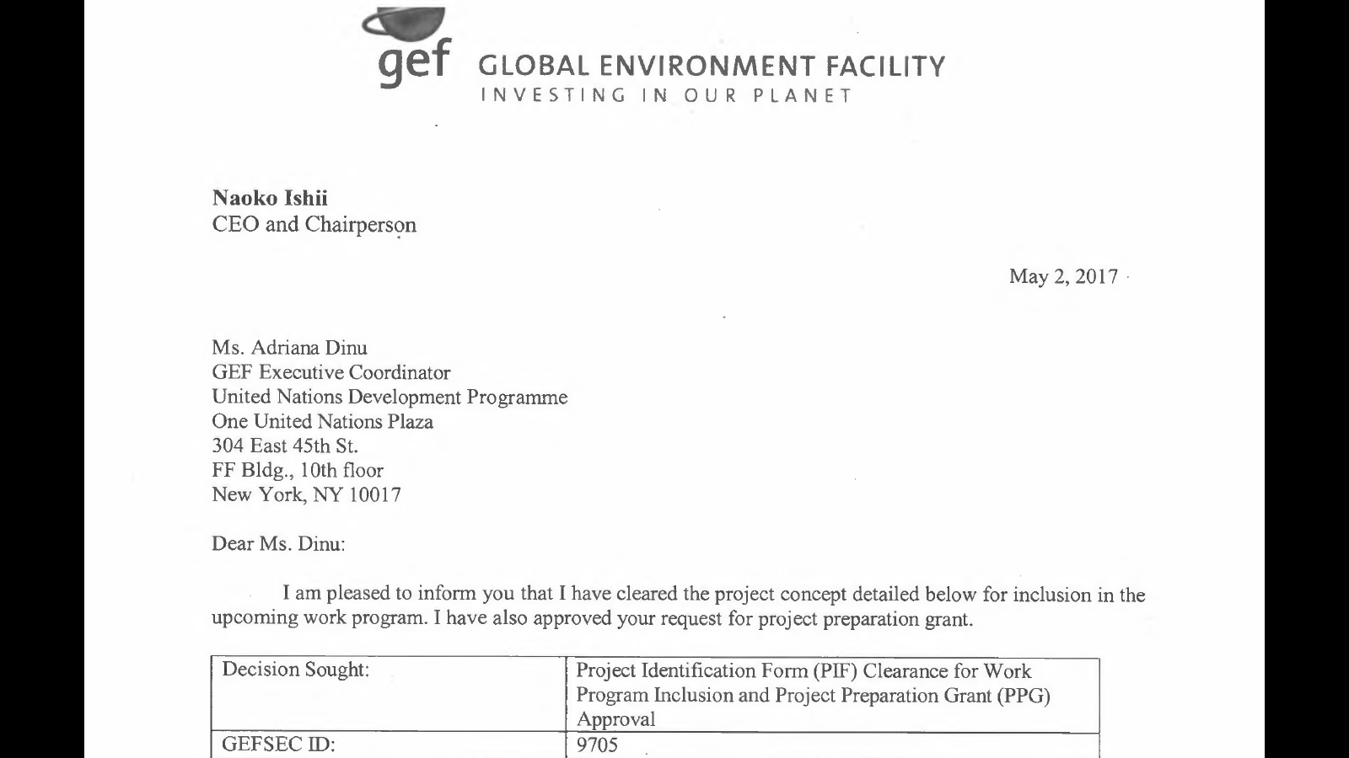

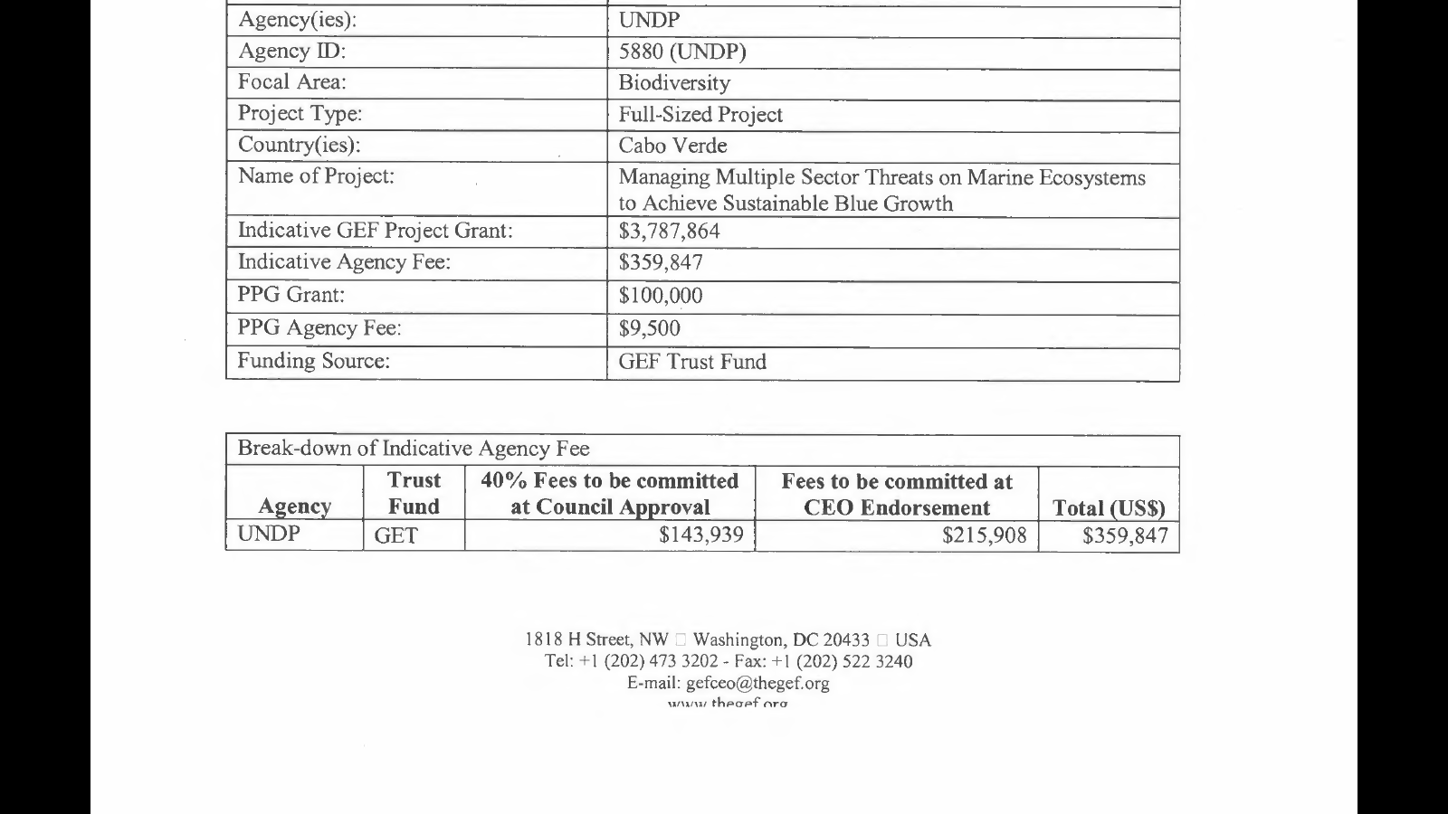

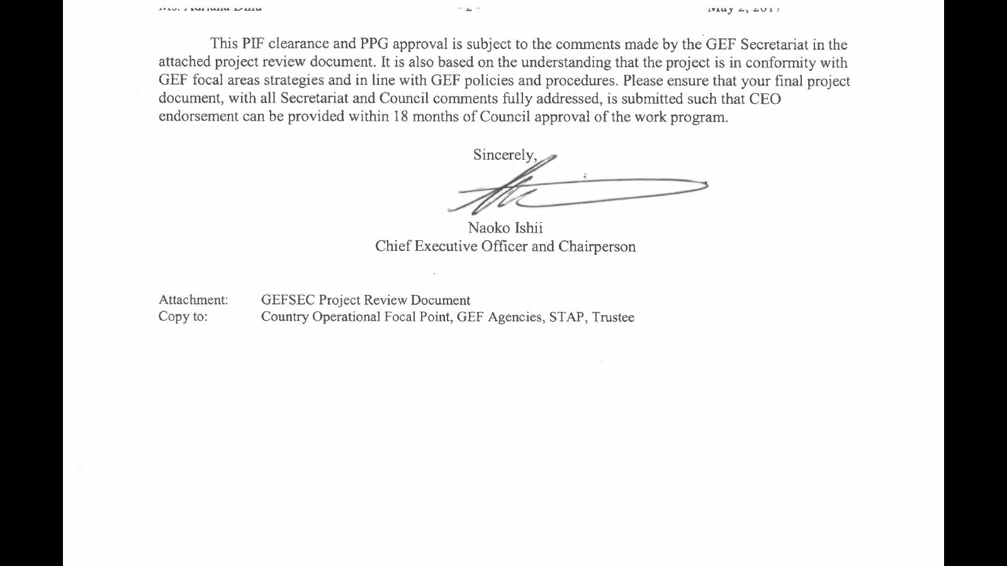



## Annex 2: Draft Terms of Reference (TORs) of Consultants Financed by the Project Preparatory Grant (GEF PPG)

If appropriate, please use this guidance to support the preparation of PPG TORs. Full standard TOR templates will be prepared by the UNDP-GEF RBM team in the coming months. The cost per consultancy week and number of weeks provided below are indicative only and may be revised.

|  |  |
| --- | --- |
| **Position, Type and Cost** | **Role, Deliverables and Qualifications** |
| ***STANDARD FIELDS TO COMPLETE***  **Position:** *[title]*  **Type:** *[IC or NC]*  **Cost per person week:** *[in US$]*  **Number of person weeks needed:** *[number of weeks]* | **Role**  *[brief description]*  **Deliverables**  *[list based on PPG Components A, B and C]*  **Qualifications**   * Master’s degree or higher in a relevant field, such as *[add relevant fields/degrees]*; * Minimum *[complete]* years of demonstrable experience in the technical area of *[complete]*; * Fluency in written and spoken English and *[complete]*; * *[other skills]* |
| ***TEAM LEADER EXAMPLE***  **Position:** *[Focal Area]* Project Development Specialist (GEF PPG Team Leader)  **Type:** IC  **Cost per person week:** US$2,500  **Number of person weeks needed:** 22 weeks | **Role**  The *[Focal Area]* Project Development Specialist will be the GEF PPG Team Leader and will be responsible for quality assurance and timely preparation of all reports and documentation, including the finalized UNDP Project Document (ProDoc) and CEO Endorsement Request, with all mandatory and project specific Annexes and supporting documentation. S/he will be responsible for managing all consultants on the GEF PPG Team, and coordinating the Team’s work.  **Deliverables**   1. Management of the GEF PPG Team    1. Define and submit a **detailed methodology and work plan** in consultation with the other consultants with clear delegation of responsibilities for the International Consultants (ICs) and National Consultants (NCs);    2. Ensure that project development is **participatory, gender-responsive and based on extensive stakeholder engagements**; and    3. Verify and ensure that all project components are **technically sound and cost effective**. 2. Preparatory Technical Studies and Reviews (Component A): With inputs from the other national and international consultants, as detailed in their respective TORs:    1. Compile **baseline/situational analysis** for the full-size project (FSP). This will include a precise definition of baseline projects, activities, budgets, goals and co-financial links to GEF outcomes; definition of GEF incremental value per outcome and output; and presentation of results of the incremental cost-analysis in matrices as appropriate;    2. Oversee the **stakeholder analysis and consultations** and ensure that they are complete and comprehensive;    3. Ensure the preparation of the **gender analysis** and ensure its findings are meaningfully integrated into the project’s strategy, theory of change and results framework;    4. Ensure action points, including risk assessments, from the **UNDP Social and Environmental Screening Procedure** (SESP) at the PIF stage (“pre-screening”) are fully implemented during the PPG, and update that screening in an iterative fashion throughout the PPG, as appropriate;    5. Conduct/oversee the **identification of the project sites**, with documentation of selection criteria;    6. Oversee the consultations with partners regarding **financial planning**; and    7. Ensure completion of **any additional studies** that are determined to be needed for the preparation of the ProDoc and all other final outputs. 3. Formulation of the ProDoc, CEO Endorsement Request and Mandatory and Project Specific Annexes (PPG Component B): With inputs from the other national and international consultants, as detailed in their respective TORs, and based on international best practice:    1. Develop, present and articulate the project’s **theory of change**;    2. Develop the **Results Framework** in line with UNDP-GEF policy;    3. Develop a detailed **Monitoring and Evaluation Plan and Budget**;    4. Oversee and ensure the preparation of a **Stakeholder Engagement Plan**;    5. Oversee and ensure the preparation of a **Gender Action Plan and Budget**;    6. Update the **SESP** based on assessments undertaken during PPG Component A, and ensure the development of **environmental and/or social management plan(s)** for all risks identified as Moderate or High in the SESP;    7. Prepare the required **GEF tracking tool(s)**;    8. Secure and present agreements on **project management arrangements**;    9. Ensure the completion of the **required official endorsement letters**; and    10. Synthesize all analyses, studies, etc. that are prepared under PPG Components A and B to produce **the draft UNDP-GEF ProDoc, GEF CEO Endorsement, and all mandatory and project specific Annexes**, using the required templates.[[3]](#footnote-3) 4. Validation Workshop (Component C):    1. Lead the validation workshop to present, discuss and validate the final draft ProDoc and mandatory and project specific annexes, with a special focus on the SESP and any management plans; and    2. Oversee all necessary revisions that arise during the workshop.    3. Ensure completion of Validation Workshop Report. 5. Final Deliverables:    1. Consolidation of all technical and consultation inputs including from national stakeholders, UNDP, GEF Secretariat, STAP and GEF Council, into a well written and concise UNDP ProDoc with all required sections and Annexes, in line with the standard UNDP-GEF ProDoc template and annotated guidance;    2. Completion of the GEF CEO Endorsement Request;    3. All documentation from GEF PPG (including technical reports, etc.); and    4. Validation Workshop Report.   **Qualifications**   * Master’s degree or higher in a relevant field, such as *[add relevant fields/degrees]*; * Minimum *[complete]* years of demonstrable experience in the technical area of *[complete]*; * Fluency in written and spoken English and *[complete]*;   *[other skills]* |
| ***M&E EXAMPLE***  **Position:** Impact Assessment and M&E Expert  **Type:** IC  **Cost per person-week:** US$4,000  **Number of person-weeks needed:** 8 weeks | **Role**  The Impact Assessment and M&E Expert will…  **Deliverables**   1. Preparatory Technical Studies and Reviews (PPG Component A): Prepare inputs and support the required analyses/studies, as agreed with the PPG Team Leader, including:    1. Prepare inputs for the **baseline/situational analysis** for the full-size project (FSP). This will include a precise definition of baseline projects, activities, budgets, goals and co-financial links to GEF outcomes; definition of GEF incremental value per outcome and output; and presentation of results of the incremental cost-analysis in matrices;    2. Support the **stakeholder analysis and consultations** and ensure that they are complete and comprehensive;    3. Support the preparation of the **gender analysis**;    4. Support the action points, including risk assessments, from the **UNDP Social and Environmental Screening Procedure** (SESP) at the PIF stage (“pre-screening”) are fully implemented during the PPG, and support the iterations of that screening in an iterative fashion throughout the PPG, as appropriate;    5. Support the **identification of the project sites**, with documentation of selection criteria;    6. Support the completion of **any additional studies** that are determined to be needed for the preparation of the ProDoc and all other final outputs. 2. Formulation of the ProDoc, CEO Endorsement Request and Mandatory and Project Specific Annexes (PPG Component B): Prepare inputs and support the development of final PPG deliverables, as agreed with the PPG Team Leader. 3. Validation Workshop (PPG Component C):    1. Contribute to the validation workshop; and    2. Support all necessary revisions that arise during the workshop, as appropriate. 4. Final Deliverables:    1. *[complete]*   **Qualifications**   * Master’s degree or higher in a relevant field, such as *[add relevant fields/degrees]*; * Minimum *[complete]* years of demonstrable experience in the technical area of *[complete]*; * Fluency in written and spoken English and *[complete]*;   *[other skills]* |
| ***GENDER[[4]](#footnote-4) & SAFEGUARDS EXAMPLE***  **Position:** Stakeholder Engagement and Gender Specialist  **Type:** NC  **Cost per person-week:** US$1,200  **Number of person-weeks needed:** 8 weeks | **Role**  The Stakeholder Engagement and Gender Specialist will…  **Deliverables**   1. Preparatory Technical Studies and Reviews (PPG Component A): Prepare inputs and support the required analyses/studies, as agreed with the PPG Team Leader, including:    1. Lead and advise on the **stakeholder analysis and consultations** and ensure that they are complete and comprehensive;    2. Prepare the **gender analysis** and work closely with the Team Leader to ensure its findings are meaningfully integrated into the project’s strategy, theory of change and results framework;    3. Support action points, including risk assessments, from the **UNDP Social and Environmental Screening Procedure** (SESP) at the PIF stage (“pre-screening”) are fully implemented during the PPG, and update that screening in an iterative fashion throughout the PPG, as appropriate; and    4. Support completion of **any additional studies** that are determined to be needed for the preparation of the ProDoc and all other final outputs. 2. Formulation of the ProDoc, CEO Endorsement Request and Mandatory Annexes as well as project specific annexes (PPG Component B): Prepare inputs and support the required analyses/studies, as agreed with the PPG Team Leader, including:    1. Prepare the **Stakeholder Engagement Plan**;    2. Prepare the **Gender Action Plan and Budget**;    3. Contribute to the updated the **SESP**, as needed, based on assessments undertaken during PPG Component A;    4. Support the development of **environmental and/or social management plan(s)** for all risks identified as Moderate or High in the SESP; and    5. Support the agreements on **project management arrangements**. 3. Validation Workshop (PPG Component C): 4. Contribute to the validation workshop; and 5. Support all necessary revisions that arise during the workshop, as appropriate. 6. Final Deliverables:    1. *[complete]*   **Qualifications**   * Master’s degree or higher in a relevant field, such as *[add relevant fields/degrees]*; * Minimum *[complete]* years of demonstrable experience in the technical area of *[complete]*; * Fluency in written and spoken English and *[complete]*; * *[other skills]* |

## Annex 3a: Comments on the PIF from GEF Secretariat

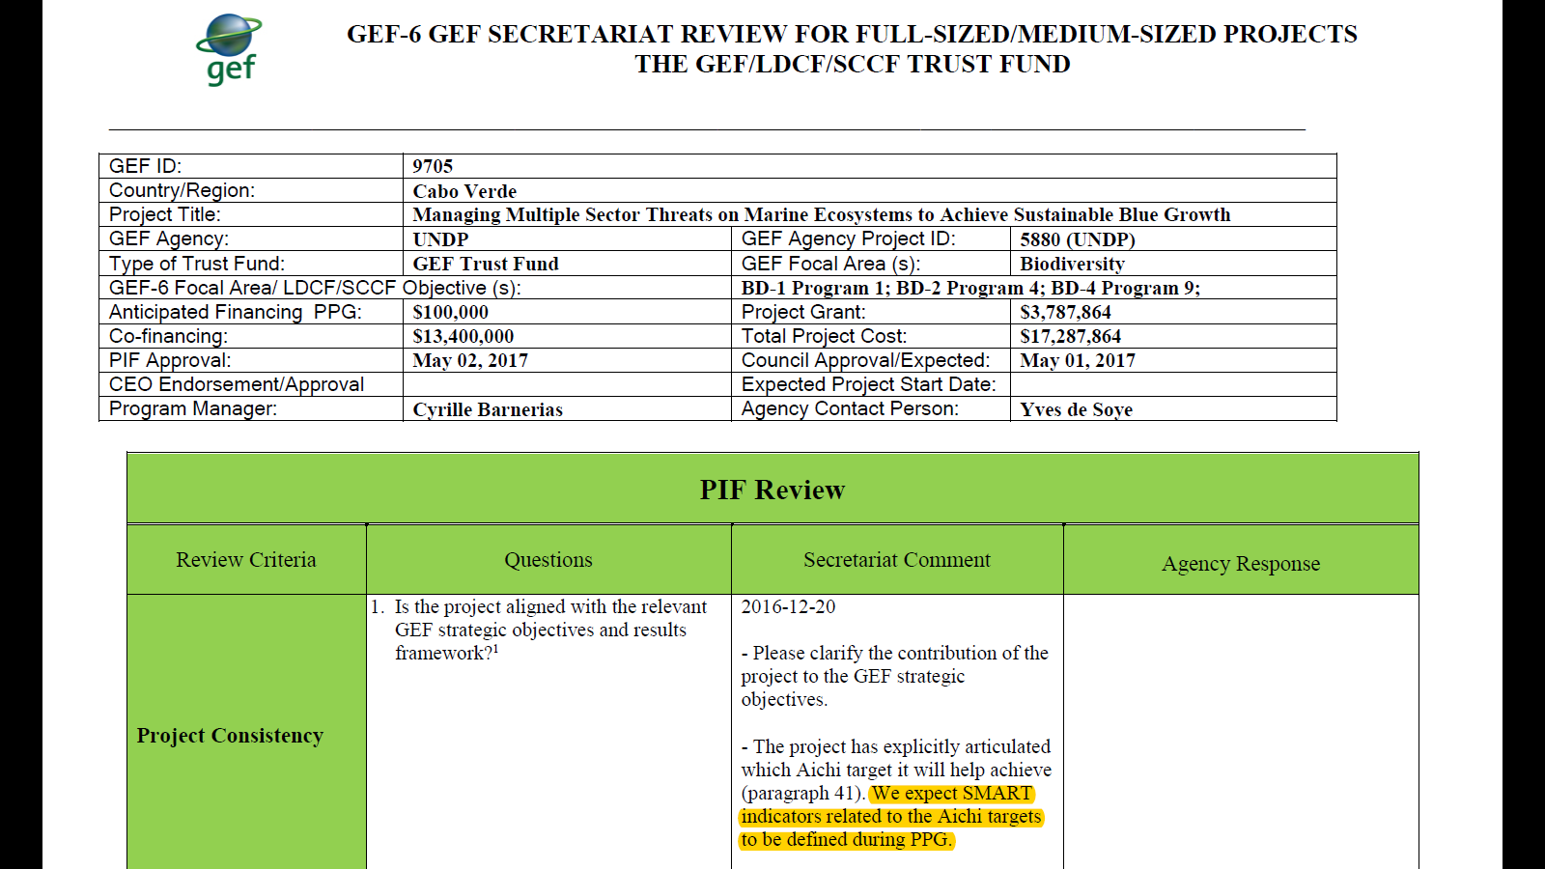

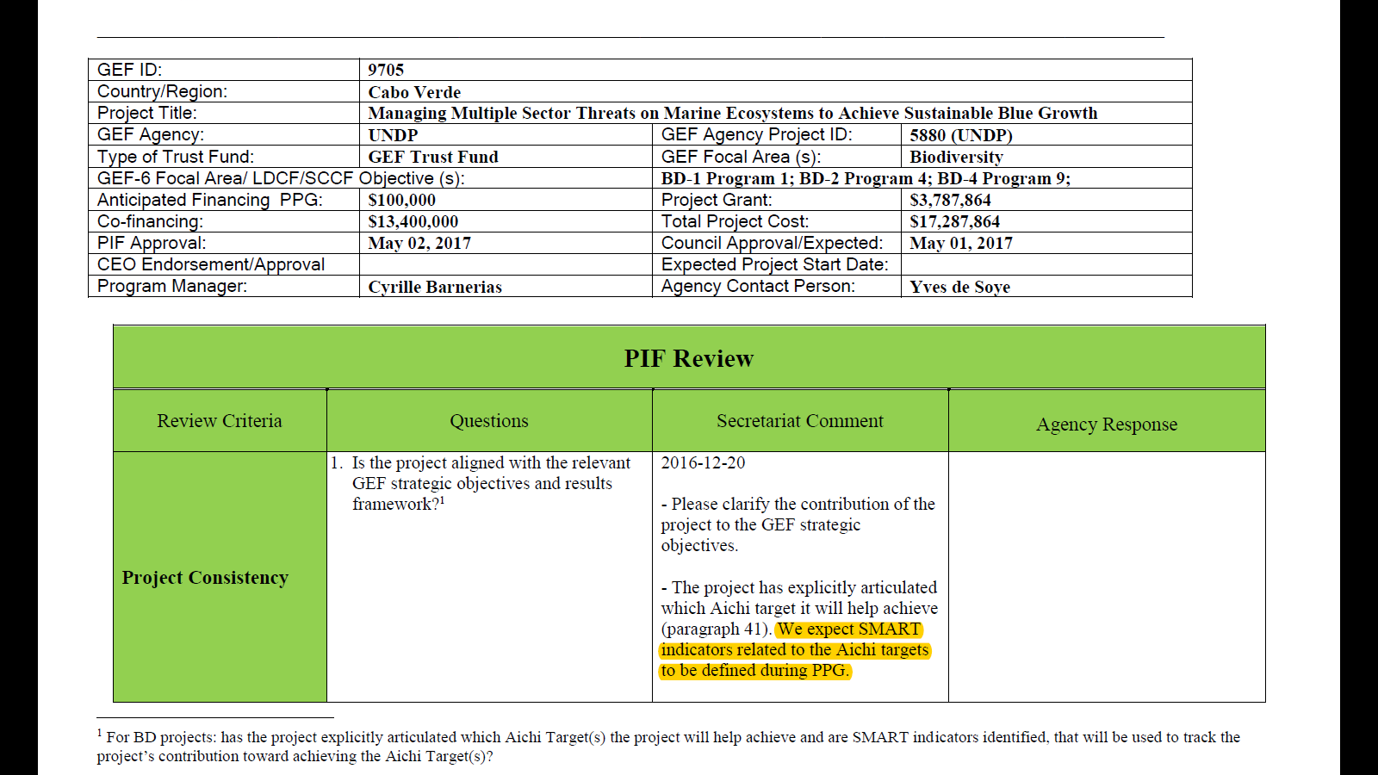

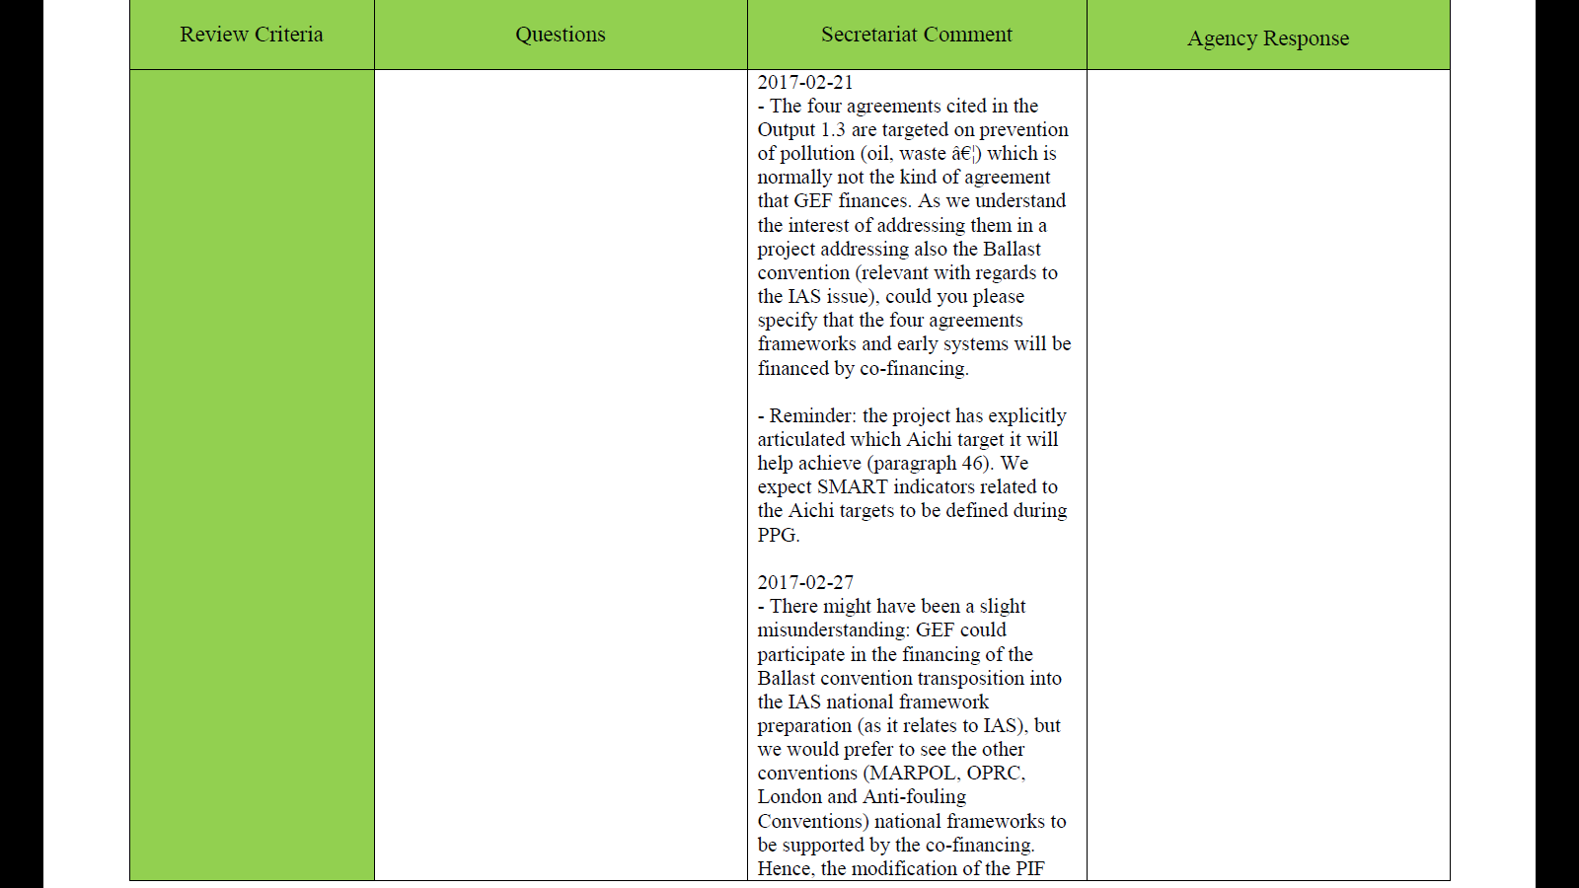

## 

## 

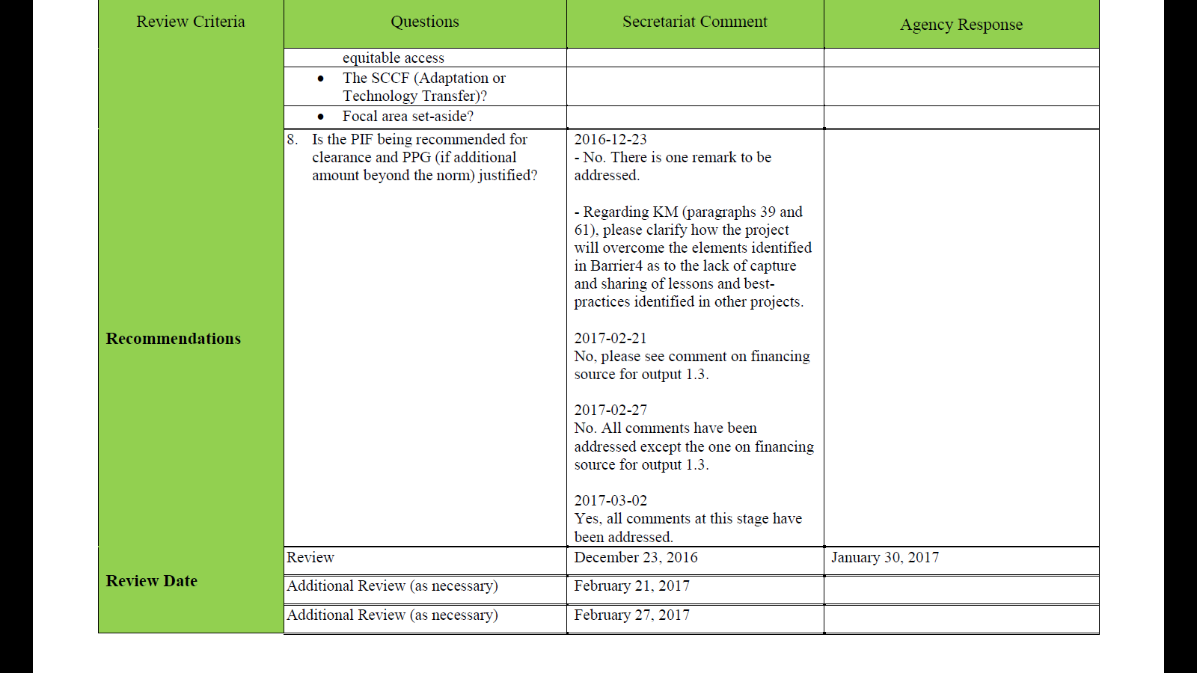

## Annex 3b: Comments on the PIF from GEF STAP

**Scientific and Technical Advisory Panel**



The Scientific and Technical Advisory Panel, administered by UNEP, advises the Global Environment Facility

(Version 5)

**STAP Scientific and Technical screening of the Project Identification Form (PIF)**

|  |  |
| --- | --- |
| Date of screening: | May 08, 2017 |
| Screener: | Virginia Gorsevski |
| Panel member validation by: | Brian Child |
| Consultant(s): |  |

1. **PIF Information** *(Copied from the PIF)*

|  |  |
| --- | --- |
| **Full-Sized Project** | **GEF Trust Fund** |
| **GEF Project ID**: | 9705 |
| **Project Duration**: | 5 |
| **Countries**: | Cabo Verde |
| **Project Title**: | Managing Multiple Sector Threats on Marine Ecosystems to Achieve Sustainable Blue Growth |
| **GEF Agencies**: | UNDP |
| **Other Executing Partners**: | Ministry of Agriculture and Environment (MAE) / General Directorate for Environment (DGA) with Ministry of Economy and Employment (MEE) / General Directorate Marine Resources (DGRM) |
| **GEF Focal Area**: | Biodiversity |

**II. STAP Advisory Response** *(see table below for explanation)*

Based on this PIF screening, STAP’s advisory response to the GEF Secretariat and GEF Agency(ies): **Concur**

**III. Further guidance from STAP**

STAP believes that the global environmental benefits targeted by this project in Cape Verde are legitimate and worthwhile and that the strategy is logical and comprehensive.

Having said that, STAP feels that the project is somewhat over-ambitious and we are concerned about the practical viability of taking on so many activities simultaneously, even after noting the assertion that Cape Verde has strong technical capacity.

For example, there are a total of 26 discrete activities, many of which are complex, require technical/system development, and involve multiple stakeholders. Component 1 alone includes no less than a dozen activities, including regulatory and policy alignment and reform (which is notoriously time consuming) conducted with a significant number of stakeholders and agencies within a budget of $USD 1.160 million. In sum, there appear to be too many moving parts for this project to be technically feasible within the time frame, budget and institutional capacity.

In addition, the risks that stakeholders will engage in, and implement, activities, policies and regulations are noted. Individually these are ranked as "medium", but together perhaps they are "high?." For example, if there are so many risks associated with using drones, is this a good approach?

Given these concerns, STAP recommends that as part of the PPG, project managers undertake a rigorous assessment of whether this complex project is feasible within the project time frame and capacity, and the capacity of implementing agencies to deliver the project. Through the project they should engage with the stakeholders that will need to be involved (through a workshop) to assess buy-in, capacity and feasibility.

The current assessment of risks does recognize these problems, but should be specifically expanded to assess the assumptions that all these actors and (often complex) technical solutions mentioned in the PIF will work in practice within budget and time frame.

|  |  |
| --- | --- |
| *STAP advisory response* | *Brief explanation of advisory response and action proposed* |
| 1. **Concur** | In cases where STAP is satisfied with the scientific and technical quality of the proposal, a simple “Concur” response will be provided; the STAP may flag specific issues that should be pursued rigorously as the proposal is developed into a full project document. At any time during the development of the project, the proponent is invited to approach STAP to consult on the design prior to submission for CEO endorsement. |
| 1. **Minor issues to be considered during project design** | STAP has identified specific scientific /technical suggestions or opportunities that should be discussed with the project proponent as early as possible during development of the project brief. The proponent may wish to:  (i) Open a dialogue with STAP regarding the technical and/or scientific issues raised.  (ii) Set a review point at an early stage during project development, and possibly agreeing to terms of reference for an independent expert to be appointed to conduct this review.  The proponent should provide a report of the action agreed and taken, at the time of submission of the full project brief for CEO endorsement. |
| 1. **Major issues to be considered during project design** | STAP proposes significant improvements or has concerns on the grounds of specified major scientific/technical methodological issues, barriers, or omissions in the project concept. If STAP provides this advisory response, a full explanation would also be provided. The proponent is strongly encouraged to:  (i) Open a dialogue with STAP regarding the technical and/or scientific issues raised; (ii) Set a review point at an early stage during project development including an independent expert as required.  The GEF Secretariat may, based on this screening outcome, delay the proposal and refer the proposal back to the proponents with STAP’s concerns.  The proponent should provide a report of the action agreed and taken, at the time of submission of the full project brief for CEO endorsement. |

## Annex 3c: Comments on the PIF from GEF Council

From: Cyrille Frederic Marie Barnerias [mailto:cbarnerias@thegef.org]   
Sent: 15 June 2017 23:05  
To: Yves de Soye  
Subject: RE: Project 9705 - comments from council members

Dear Yves,

Yes, we must ensure that these comments are fully taken into account in the preparation of the project documents that come back to the GEFSEC for endorsement. So, it is not a new review of the PIF, but rather a work to be done during PPG.

Best regards,

Cyrille

From: Yves de Soye [<mailto:yves.desoye@undp.org>]   
Sent: Thursday, June 15, 2017 4:58 PM  
To: Cyrille Frederic Marie Barnerias <[cbarnerias@thegef.org](mailto:cbarnerias@thegef.org)>  
Cc: Glynis Afiong Barber <[gbarber@thegef.org](mailto:gbarber@thegef.org)>; [midori.paxton@undp.org](mailto:midori.paxton@undp.org); Lela Fikrou <[lela.fikrou@undp.org](mailto:lela.fikrou@undp.org)>; Akiko Yamamoto <[akiko.yamamoto@undp.org](mailto:akiko.yamamoto@undp.org)>  
Subject: RE: Project 9705 - comments from council members

Dear Cyrille

Many thanks for passing on these comments from GEF Council members, which are all well noted and we will carefully consider.

Do I understand you correctly that this should be addressed during the PPG when preparing the PRODOC and in subsequent implementation – as opposed to a further review of the PIF?

Many thanks for clarifying this and best wishes

|  |  |
| --- | --- |
|  |  |
| UNDP-logo-jpg | Yves de Soye  Regional Technical Advisor, Ecosystems & Biodiversity  Global Environmental Finance Unit  Bureau for Policy and Programme Support  UNDP Istanbul Regional Hub, Turkey  E: [yves.desoye@undp.org](mailto:yves.desoye@undp.org). Skype: yvesdesoye.undp  [www.undp.org](http://www.undp.org) |

From: Cyrille Frederic Marie Barnerias [<mailto:cbarnerias@thegef.org>]   
Sent: 15 June 2017 22:24  
To: Yves de Soye  
Cc: [gbarber@thegef.org](mailto:gbarber@thegef.org)  
Subject: Project 9705 - comments from council members

Dear Mr. de Soye,

|  |
| --- |
| Please find below the comments from council members that we received related to project 9705 (Managing multiple sector threats on marine ecosystems to achieve sustainable blue growth). |

The comments will also be uploaded to PMIS.

From **France**:

We globally support this proposal and would suggest reinforcing two points:   
  
1. to reconcile national frameworks for maritime sector and regional approaches, for instance on sustainable management of fisheries, aquaculture or maritime traffic, and to secure the collaboration of all stakeholders, build on existing regional multi-stakeholder initiatives covering terrestrial and marine ecosystems, such as Abidjan Convention, as a basis for future development of Marine Spatial Plans ;   
  
2. to motivate changes in local practices and support marine biodiversity conservation :   
- Use the economic lever and support sustainable economic alternatives activities ;  
- Support at regional level “peer to peer” exchanges on best local practices

From **US**:

1) This proposal seeks to introduce drones into the conservation and management of a large area across multiple islands. This is a worthwhile innovation. Since it is new in this area, the proposal would benefit from greater clarity in the listed objectives. Particularly, we would like to see clearly identified target regions or Protected Areas and specific objective or outcome to measure each initiative.   
  
2) What plans does the project have to share lessons learned from this project? We imagine many other regions of the world would benefit from such information given the nascency of this technology application.  
  
3) Financial institutions to enable local fisherfolk to upgrade equipment and migrate to larger operations capable of going beyond fragile local fisheries should be included in this project. This could be critical in fishery management by providing sustained employment if limitations for certain seasons are successfully imposed -- the additional equipment would enable fisherfolk to fish in other areas outside of the controlled areas.  
  
4) The proposal should specify how the project will engage local farmers, many of whom are women.   
  
5) We suggest adding a data collection component to the project, in particular for the artisanal fisheries sector. It seems there is little management and enforcement on the artisanal sector, which the proposed activities would target, yet there is no mention of data gaps, collection, sharing of this information with other entities.  
  
6) We suggest coordinating with the International Commission for the Conservation of Atlantic Tunas (ICCAT, <https://www.iccat.int/en/>). Although this GEF project goes beyond the scope of ICCAT, there are lessons and collaboration that could be beneficial to both sides, in particular on data collection, enforcement opportunities, stock assessment information, and artisanal fisheries work.   
  
7) There are many synergies between elements of this project and the FAO-implemented Canary Current Large Marine Ecosystem (CCLME) project’s Strategic Action Programme (SAP). This is an example of an opportunity for coordination across the focal areas, as this project is within the Biodiversity focal area, but has strong links to the CCLME Project, which is within the International Waters focal area. Each of the four Project Components of the PIF under review has important connections to CCLME activities, including the sustainable management of fisheries and the preservation of critical habitats in marine and coastal areas. For example, Component 1 describes the development of national frameworks for maritime sector planning and threat management through an Integrated Marine Spatial Plan. We recommend that this project coordinate with the activities of the CCLME SAP.  
  
8) In addition, Component 4 should coordinate with the GEF Project Strengthening Global Governance of Large Marine Ecosystems and Their Coasts through Enhanced Sharing and Application of LME/ICM/MPA Knowledge and Information Tools, which will harness knowledge experience gained through previous LME projects.

From **Germany**:

Germany approves the following PIF in the work program but asks that the following comments are taken into account:  
  
Suggestions for improvements to be made during the drafting of the final project proposal:  
  
· The full proposal should clearly explain in Project component 1 (project outputs 1.1 and 1.2), how the government authority that will oversee and lead the Integrated Marine Spatial Planning Process, will be strengthened and how the necessary policy changes will be implemented with GOCV. This is very important, given that coastal and marine policies appear to be very sectoral in Cape Verde and that the management authority does not have a strong mandate.  
  
· Germany seeks clarification on the nation-wide marine certification of fisheries products through MSC (Project component 1, output 1.5). MSC certification is usually specific for a given fish stock and fishing fleet. Multiple species, fishing fleets and gear types are very difficult to certify, especially in data-deficient fisheries. Please specify which fisheries would be included in the assessment and if sufficient data are available to conduct the analysis.  
  
· The final proposal should ensure that gender issues and impacts are not only monitored but explain how gender issues are addressed in the specific interventions.

Best regards,

|  |  |
| --- | --- |
| **logo-gef** | **Cyrille Barnerias** | Sr. Environmental Specialist 🌊  Office : (+1) 202-473-8871 | Cell : (+1) 202-280-0646 | [cbarnerias@thegef.org](mailto:cbarnerias@thegef.org)  Mail stop: N-800 | 1818 H Street NW - Washington DC 20433 USA  Street address: 8th floor-191a  1899 Pennsylvania Ave NW – Washington DC USA \_\_\_\_\_\_\_\_\_\_\_\_\_\_\_\_\_\_\_\_\_\_\_\_\_\_\_\_\_\_\_\_\_\_\_\_\_\_\_\_\_\_\_\_\_\_\_\_\_\_\_\_\_\_\_\_\_\_\_\_\_\_\_\_\_\_\_\_\_\_  **Global Environment Facility** [**Thegef.org**](http://www.thegef.org/) **|** [**Facebook**](http://www.facebook.com/thegef1) **|** [**Twitter**](http://twitter.com/theGEF) **|** [**YouTube**](http://www.youtube.com/GEFSecretariat) |

1. For programs, the reference to “PIF” in this template should be understood as the Child Project Concept Note; the PFD would be the document on which submission deadlines are based and for which GEF Council / STAP comments need to be addressed during the PPG. Please revise text in the template as needed for programs. [↑](#footnote-ref-1)
2. Edit as necessary. Include other Agency as necessary. [↑](#footnote-ref-2)
3. Please verify with the UNDP-GEF team that the correct templates are being used. [↑](#footnote-ref-3)
4. Standard template for hiring a gender expert as part of the PPG Team is available [here](https://intranet.undp.org/unit/bpps/sdev/gef/_layouts/15/WopiFrame.aspx?sourcedoc=/unit/bpps/sdev/gef/Gender%20Library/TOR%20Template%20Gender%20Consultant.docx&action=default&Source=https%3a//intranet.undp.org/unit/bpps/sdev/gef/Gender%2520Library/Forms/AllItems.aspx&DefaultItemOpen=1&DefaultItemOpen=1). [↑](#footnote-ref-4)